Software Testing Database

Cody Strange, Lincoln Harmston

CS3520-002

Fall 2022

Project 1

Oracle

Interview

We sat down with one of our classmates (never got his name) who works in the field of testing. He was able to describe the process of to us that we modeled our E-R diagram after. He went over the process of Engineers that would create a feature to add to the current project and then another Engineer that would write and run a test on said feature. There could be multiple tests run on one feature and you would want to write the tests so you could reuse them on different features if possible. He recommended to us to have our Engineer and Software as one entity and just have an attribute saying which role or type they were. He really helped us simplify our E-R diagram and narrow the scope of it to this project.

ER Diagram

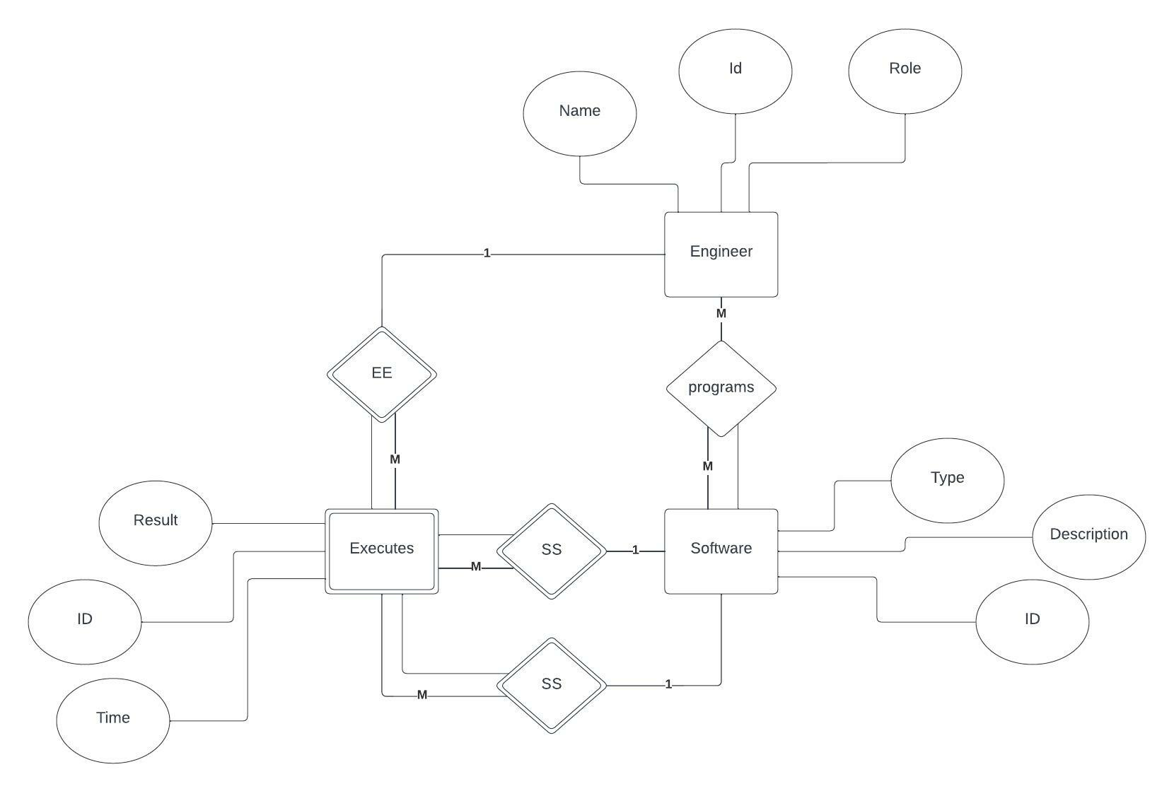

Schemas

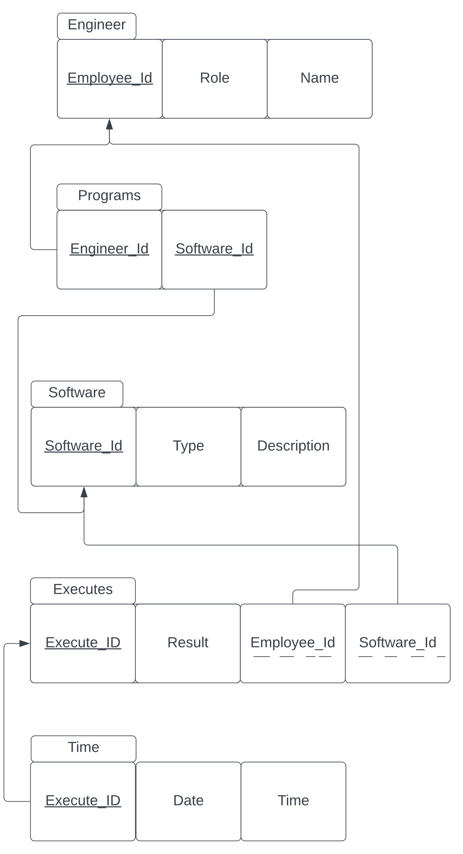

Normalization

# Table one: Engineer

**First Normal Form:** The Engineer table is in 1NF because its attributes (Employee_Id, Role, and Name) are not multi-value attributes, therefore the table is in 1NF.

**Second Normal Form:** The Engineer table is in 2NF because it is 1NF and both non-key attributes (Role, Name) are fully functionally dependent on the primary key.

**Third Normal Form:** The Engineer table is in 3NF because it is in 2NF and it has no transitive dependencies, we know it cannot have any transitive dependencies because all non-key attributes are solely dependent on the single key attribute.

**Boyce-Codd Normal Form:** The Engineer table is in BCNF because it is in 3NF, and no key attributes are dependent on a non-key attribute.

# Table Two: Programs

**First Normal Form:** The Programs table is in 1NF because its attributes (Engineer_Id, and Software_Id) are not multi-value attributes, therefore the table is in 1NF.

**Second Normal Form:** The Programs table is in 2NF because it is 1NF and all of its attributes (Engineer_Id, and Software_Id) are primary keys, therefore all non-key attributes are fully functionally dependent on the primary key.

**Third Normal Form:** The Programs table is in 3NF because it is in 2NF and it has no transitive dependencies, we know it cannot have any transitive dependencies because it only has primary key attributes, therefore all non-key attributes are solely dependent on the single key attribute.

**Boyce-Codd Normal Form:** The Programs table is in BCNF because it is in 3NF and it only has primary keys, therefore no key attributes are dependent on non-key attributes.

# Table Three: Software

**First Normal Form:** The Software table is in 1NF because its attributes (Software_Id, and Type, Description) are not multi-value attributes, therefore the table is in 1NF.

**Second Normal Form:** The Software table is in 2NF because it is 1NF and all of its attributes (Type and Description) are fully functionally dependent primary key.

**Third Normal Form:** The Software table is in 3NF because it is in 2NF and it has no transitive dependencies, we know it cannot have any transitive dependencies because all non-key attributes are solely dependent on the single key attribute.

**Boyce-Codd Normal Form:** The Software table is in BCNF because it is in 3NF and no key attributes are dependent on a non-key attribute.

# Table Four: Executes

**First Normal Form:** The Executes table is in 1NF because its attributes (Employee_Id, Result, Execute_Id, and Software_Id) are not multi-value attributes, therefore the table is in 1NF.

**Second Normal Form:** The Executes table is in 2NF because it is 1NF and all non-key attributes (Result, Employee_Id, and Software_Id) are fully functionally dependent on the primary key.

**Third Normal Form:** The Executes table is in 3NF because it is in 2NF and it has no transitive dependencies, we know it cannot have any transitive dependencies because all non-key attributes are solely dependent on the single primary key attribute.

**Boyce-Codd Normal Form:** The Executes table is in BCNF because it is in 3NF, and no key attributes are dependent on a non-key attribute.

# Table Five: Time

**First Normal Form:** The Executes table is in 1NF because its attributes (Execute_Id, Date, and Time) are not multi-value attributes, therefore the table is in 1NF.

**Second Normal Form:** The Executes table is in 2NF because it is 1NF and all non-key attributes (Date and Time) are fully functionally dependent on the primary key.

**Third Normal Form:** The Executes table is in 3NF because it is in 2NF and it has no transitive dependencies, we know it cannot have any transitive dependencies because all non-key attributes are solely dependent on the single primary key attribute.

**Boyce-Codd Normal Form:** The Executes table is in BCNF because it is in 3NF, and no key attributes are dependent on a non-key attribute.

Oracle Database

# Engineer table

Table SQL

CREATE TABLE Engineer (

Employee_Id VARCHAR(9),

Role VARCHAR(16),

Name VARCHAR(32),

CONSTRAINT Engineer_empId_pk PRIMARY KEY(Employee_Id),

CONSTRAINT Engineer_Role CHECK(Role = 'Test' OR Role = 'Software'));

Tuple SQL

INSERT INTO Engineer

VALUES('000000001', 'Test', 'John Smith');

INSERT INTO Engineer (Employee_Id, Role, Name)

WITH names as (

SELECT '000000005', 'Test', 'mary Strange' FROM dual UNION ALL

SELECT '000000006', 'Software', 'Ritchie Janey' FROM dual UNION ALL

SELECT '000000007', 'Test', 'Gary Brown' FROM dual UNION ALL

SELECT '000000008', 'Software', 'Tori Kimmie' FROM dual UNION ALL

SELECT '000000009', 'Software', 'Finlay Lark' FROM dual UNION ALL

SELECT '000000010', 'Test', 'Linton Nona' FROM dual

)

SELECT * FROM names

INSERT INTO Engineer (Employee_Id, Role, Name)

WITH names as (

SELECT '000000003', 'Test', 'Cody Strange' FROM dual UNION ALL

SELECT '000000004', 'Software', 'Lucy Smith' FROM dual

)

SELECT * FROM names

INSERT INTO Engineer

VALUES('000000002', 'Software', 'Johnny Green');

Table Oracle

# Software table

Table SQL

CREATE TABLE Software(

Software_Id VARCHAR(9),

Type VARCHAR(16),

Description VARCHAR(500),

CONSTRAINT Software_softId_pk PRIMARY KEY(Software_Id),

CONSTRAINT Software_Type CHECK(Type= 'Software' OR Type = 'Test'));

Tuple SQL

INSERT INTO SOFTWARE

WITH names as (

SELECT '000000001', 'Test', 'Tests for bug one'FROM dual UNION ALL

SELECT '000000002', 'Software', 'Home button' FROM dual UNION ALL

SELECT '000000003', 'Test', 'Test home button' FROM dual UNION ALL

SELECT '000000004', 'Software', 'Show ad' FROM dual UNION ALL

SELECT '000000005', 'Software', 'Redirect to contact' FROM dual UNION ALL

SELECT '000000006', 'Software', 'Show username' FROM dual UNION ALL

SELECT '000000007', 'Software', 'Change password' FROM dual UNION ALL

SELECT '000000008', 'Software', 'Create new user' FROM dual UNION ALL

SELECT '000000009', 'Software', 'Voice chat button' FROM dual UNION ALL

SELECT '000000010', 'Test', 'Test voice chat' FROM dual

)

SELECT * FROM names

Table Oracle

# Programs table

Table SQL

CREATE TABLE Programs (

Employee_Id VARCHAR(9),

Software_Id VARCHAR(9),

CONSTRAINT Programs_empSoftId_pk PRIMARY KEY(Employee_Id, Software_ID),

CONSTRAINT pefk FOREIGN KEY(Employee_Id) REFERENCES Engineer(Employee_Id),

CONSTRAINT psfk FOREIGN KEY(Software_Id) REFERENCES Software(Software_Id))

Tuple SQL

INSERT INTO Programs

VALUES('000000001', '000000003');

INSERT INTO Programs

VALUES('000000001', '000000001');

INSERT INTO Programs

VALUES('000000006', '000000008');

INSERT INTO Programs

VALUES('000000001', '000000010');

INSERT INTO Programs

VALUES('000000007', '000000003');

INSERT INTO Programs

VALUES('000000004', '000000004');

INSERT INTO Programs

VALUES('000000002', '000000009');

INSERT INTO Programs

WITH names (Employee_Id, Software_Id) as (

SELECT '000000009', '000000009' FROM dual UNION ALL

SELECT '000000002', '000000005' FROM dual UNION ALL

SELECT '000000003', '000000003' FROM dual

)

SELECT * FROM names

Table Oracle

# Executes Table

Table SQL

CREATE TABLE Executes(

Execute_Id VARCHAR(9),

Result VARCHAR(8),

Employee_Id VARCHAR(9),

Software_Id VARCHAR(9),

CONSTRAINT Executes_exId_pk PRIMARY KEY(Execute_Id),

CONSTRAINT eefk FOREIGN KEY (Employee_Id) REFERENCES Engineer(Employee_Id),

CONSTRAINT esfk FOREIGN KEY (Software_Id) REFERENCES Software(Software_Id));

Tuple SQL

INSERT INTO Executes

WITH names (Execute_Id, Result, Employee_Id, Software_Id) as (

SELECT '000000001', 'Fail', '000000003', '000000003' FROM dual UNION ALL

SELECT '000000002', 'Fail', '000000001', '000000010' FROM dual UNION ALL

SELECT '000000003', 'Pass', '000000001', '000000010' FROM dual UNION ALL

SELECT '000000004', 'Fail', '000000003', '000000003' FROM dual UNION ALL

SELECT '000000005', 'Pass', '000000001', '000000001' FROM dual UNION ALL

SELECT '000000006', 'Pass', '000000001', '000000010' FROM dual UNION ALL

SELECT '000000007', 'Pass', '000000001', '000000003' FROM dual UNION ALL

SELECT '000000008', 'Pass', '000000003', '000000003' FROM dual UNION ALL

SELECT '000000009', 'Fail', '000000007', '000000003' FROM dual UNION ALL

SELECT '000000010', 'Pass', '000000007', '000000003' FROM dual

)

SELECT * FROM names

Table Oracle

# Time Table

Table SQL

CREATE TABLE Time(

Execute_Id VARCHAR(9),

DOB DATE,

Time VARCHAR(5),

CONSTRAINT Time_TId_pk PRIMARY KEY(Execute_Id),

CONSTRAINT tefk FOREIGN KEY (Execute_Id) REFERENCES Executes(Execute_Id));

Tuple SQL

INSERT INTO Time

WITH names (Execute_Id, DOB, Time) as (

SELECT '000000001', '12/01/2021', '10:15' FROM dual UNION ALL

SELECT '000000002', '12/09/2021', '15:10' FROM dual UNION ALL

SELECT '000000003', '12/01/2021', '01:55' FROM dual UNION ALL

SELECT '000000004', '01/10/2022', '13:22' FROM dual UNION ALL

SELECT '000000005', '01/09/2022', '11:15' FROM dual UNION ALL

SELECT '000000006', '02/03/2022', '19:17' FROM dual UNION ALL

SELECT '000000007', '02/10/2022', '17:17' FROM dual UNION ALL

SELECT '000000008', '02/07/2022', '11:05' FROM dual UNION ALL

SELECT '000000009', '03/11/2022', '10:16' FROM dual UNION ALL

SELECT '000000010', '03/10/2022', '05:15' FROM dual

)

SELECT * FROM names

Table Oracle

**SQL Queries**

# Query One

Description

Get the name of every test engineer

SQL

SELECT name

FROM Engineer

WHERE Role = 'Test'

Table

# Query two

Description

Get all of the test ids and descriptions of failed tests

SQL

SELECT Software.Software_Id, Software.Description

FROM Software

JOIN Executes

ON Executes.Software_Id = Software.Software_Id

WHERE Result = 'Fail';

Table

# Query three

Description

Get all of the test ids and descriptions of passed tests

SQL

SELECT Software.Software_Id, Software.Description

FROM Software

JOIN Executes

ON Executes.Software_Id = Software.Software_Id

WHERE Result = 'Pass';

Table

# Query four

Description

What time the tests that failed were ran and the names of the engineer who ran them

SQL

SELECT Software.Software_Id, Software.Description, Executes.Result, Time.DOB, Time.Time, Engineer.Name

FROM Software

JOIN Executes

ON Executes.Software_Id = Software.Software_Id

JOIN Time

ON Time.Execute_Id = Executes.Execute_Id

JOIN Programs

ON Programs.Software_Id = Software.Software_Id

JOIN Engineer

ON Engineer.Employee_Id = Programs.Employee_Id

WHERE Result = 'Fail';

Table

# Query five

Description

What tests did the employee Cody Strange work on

SQL

SELECT Software.Software_Id, Software.Description, Engineer.Name

FROM Software

JOIN Programs

ON Programs.Software_Id = Software.software_Id

JOIN Engineer

ON Engineer.Employee_Id = Programs.Employee_Id

Where Engineer.Name = 'Cody Strange'

Table

Report

# Entity relationship diagram review

What we learned

* We learned how to create an ER diagram
* How to simplify an ER diagram
* When to simplify an ER diagram
* Advantages of using an associative relationship

Problems we ran into

* We really overcomplicated our ER diagram the first time around
* How associative relationships work
* What entities and attributes are needed for a testing database

# Schema Review

What we learned

* How to create a schema from an ER diagram
* How to show relationships between multiple schema tables
* Why schemas are important for creating a database

Problems we ran into

* Showing the foreign keys using lucid charts
* Mislabeling an attribute in the schema
* Turning a multi-value attribute into a schema

# Normalization review

What we learned

* What each of the normalization forms are
* How to prove that our schemas are in BCNF starting from 1NF
* How to show dependencies between attributes in schemas

Problems we ran into

* Determining if how associative relationship schema was is BCNF or not
* Figuring out what BCNF meant

# SQL table creation review

What we learned

* How to create tables in SQL
* Adding constraints onto tables
* Having multiple attributes as the primary key
* How to add checks
* How to add foreign key restraints

Problems we ran into

* Adding multiple tables at a time
* Adding the check constraints to engineer role
* Thought int datatypes took parameters when they do not
* Adding a time datatype
* Named an attribute ‘data’ with the datatype ‘DATA’ and that is not allowed

# SQL tuple creation review

What we learned

* How to add multiple rows into a table at a time
* How to insert rows into a table

Problems we ran into

* Inserting multiple rows into a table
* Inserting multiple rows into a table when the table has two primary keys of the same datatype as the only attributes

# SQL query review

What we learned

* How to come up with a good SQL query
* How to convert an English description of a query into a SQL query
* How to join multiple tables and grab specific values from the new table

Problems we ran into

* Deciding what SQL queries to create
* Confirming that our SQL query results are correct
* Joining tables using just the ‘from’ command

# Overall project review

What we learned

* How to get relevant information from an interview
* How to create an ER diagram
* How to create a schema from an ER diagram
* How to convert a schema into a table in Oracle
* How to fill a table with rows
* How to write SQL queries to get specific information from Oracle
* How to create a database about software testing

Problems we ran into

* Finding someone to interview
* Creating an overly complicated ER diagram
* Understanding what BCNF was exactly
* Creating multiple tables at once in Oracle
* Filling a table with multiple rows at once in Oracle